Water Wash Batch (WWB) Presentation

#1

EXCO

WWB Treatment in the Crude EXCO Flow ™ technology

By:

Hector Cruz Cueto, Engineer

2019

#2

WWB Crude Wash

* This technology was developed due to a persistent issue in the PEMEX system.
* The salt content in the crude is considerably high when it arrives at the refinery (150-400 lb/1000 bbl).
* With current sedimentation time, it is extremely hard to reach values of 5 lb/1000 bbl to be able to process product in the desalination.
* In addition to the emulsion’s formation with congenital water and cleaning water in the desalination.
* All these issues cause corrosion, soiling, high pressure in heaters, and loss of operation efficiency.
* It also presents formation of ammonium chloride and iron problems which will initiate serious soiling and corrosion issues in hydrodesulfurization plant, FCC, cookers, and heaters.

#3

WWBS Crude Wash

* The application of this treatment is necessary upon the arrival of crude oil to any refinery or distribution center.
* In preparation for the treatment the following conditions are required:
  + - Conditioning of water wash (fire retardant) using compound chemicals from EXCO Flow ™
    - The salt content (lb/1000 bbls) in the crude oil, will determine the amount of water wash for conditioning.
    - Based on the infrastructure (already installed) inject the solution for a better and more efficient mixing.
    - Let it stand in standing tanks for 7 – 12 hours.
    - Drain remaining water and after verifying resulting salt values, if results are satisfying, send to stabilizing tanks.
* **With this WWBS Crude Washing technology, it is possible to lower the salt content up to a 70% less of its original arriving value.**

#4

Maya crude’s pipeline testing

* Feasibility testing:
  + - Asphaltene: 4 – 8% unstable
    - Paraffines: 13 – 15%
    - Water and sediments: 0.5 – 3%, 0.1 – 1%
    - Salt: 150 – 400 lb/1000 bbls
    - Acidity: 3.6 -4.3%
    - Emulsion: very consistent (it contains agglomerates and added dispersants in wells)

#5

Tanks TV-2005 and TV-2006

* Maya crude’s receptor tanks testing:

**TV-2005** **TV-2006**

Asphaltene: 12.96 11.86

Paraffines: 9.75 10.92

Water and Sediments: T:0.5, M:1.2 F:24 T:0.2, M:0.5 F:26

Salt PTB: 267-280 189-242

Acidity: 3.89 3.42

Emulsion: Very Persistent Very Persistent

* The tank drainage deteriorates due to the sediment accumulation and the crude water persistent emulsion in the tanks.

#6

EXCO Flow ™ Treatment

* Based on the previous data, treatment was added to arriving crude line, tank was drained, and we obtained the following results.

RESTING TIME

Salt PTB 7 hours 11 hours 18 hours

74 26 11.6 **9.2**

68 22 10.2 **9.5**

90 22.3 13.7 **11.4**

* Based on these results, we can resolve the emulsion problem and remove salt in crude up to a 74.9% in 7 hours.

#7

Salt behavior in Maya crude as it arrives at Minatitlan refinery

Lab evaluation with EXCO Flow ™ Treatment

Salt in Maya crude

Water and sediments in Maya crude

#8

WWB process flow diagram

(Insert diagram)

#9

Experimental test endorsed by Crude Wash EXCO Flow ™

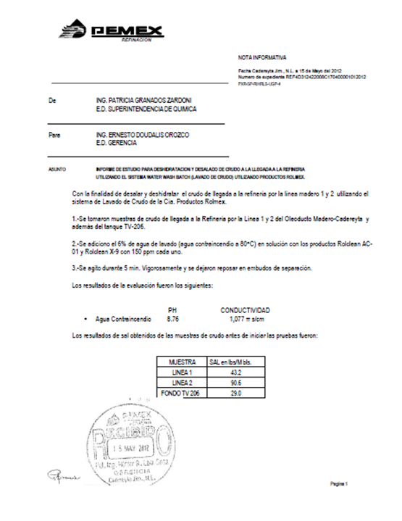 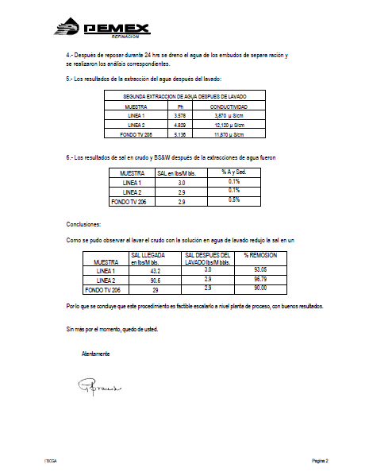

#10

Technical Proposal

* Our evaluation proposal is focused to better your operation conditions
* We propose 8 days of our WWBS in crude
* All results will always be overseen and approved by the operating personnel
* We propose to draw initial samples from arriving crude and storage tanks to determine % of water, sediment, and salt PTB with base line
* Subsequently, we will be taking samples every hour and will register amount of water drained from tank to establish a balance between congenital water, the water wash, and drained water itself
* We will provide daily reports and at the end of treatment
* We will keep all safety and environmental standards

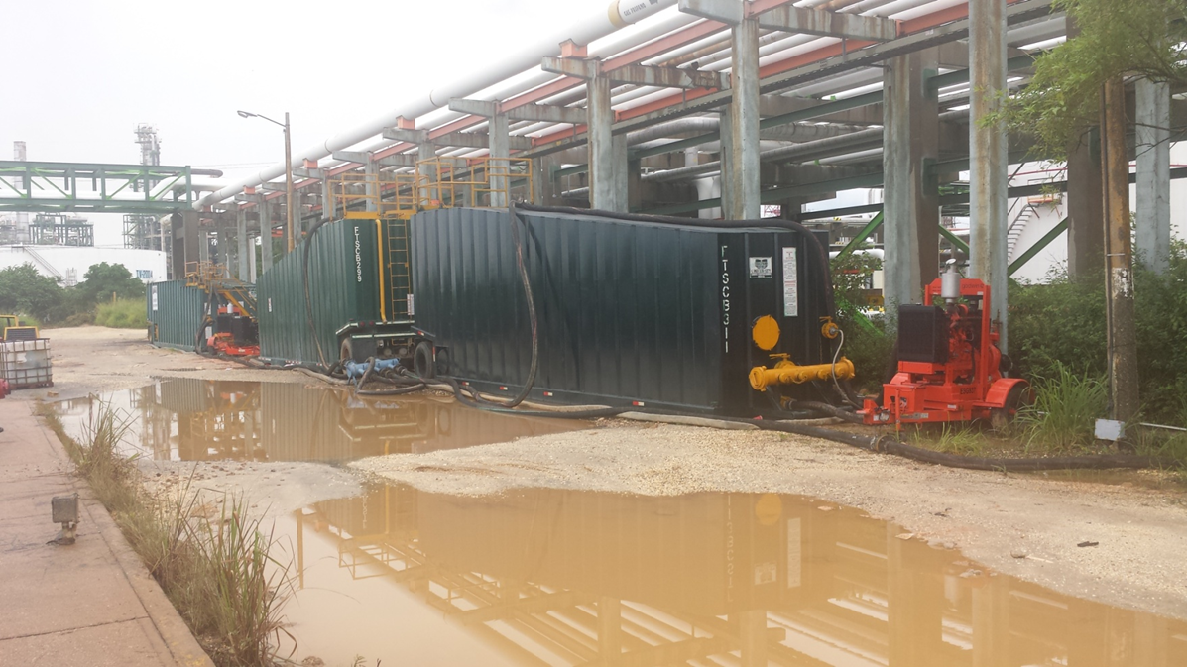#11

INJECTOR INSTALLATION TO ARRIVING CRUDE PIPELINE